Dis-Eur-Paleo-Czech Republic-26,000 BP-Final Final

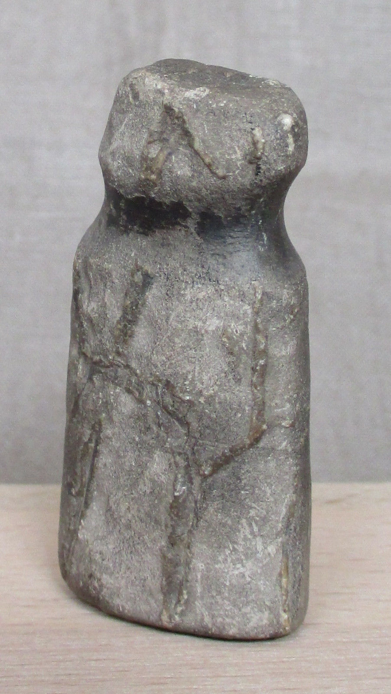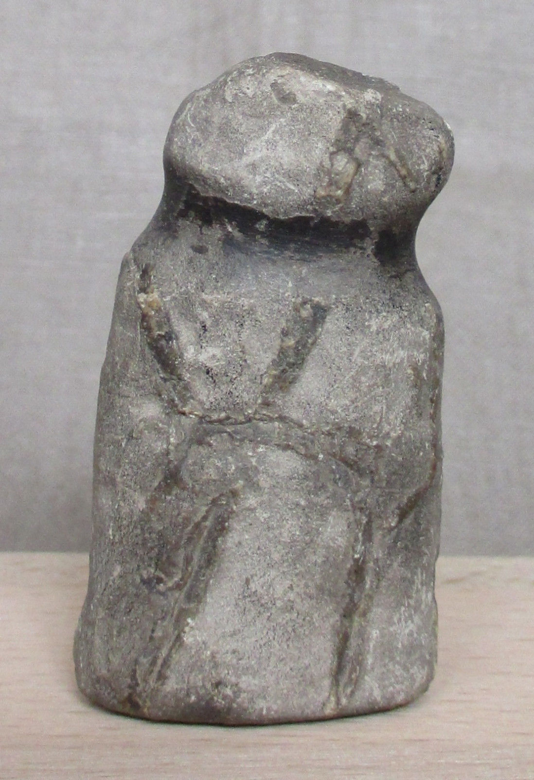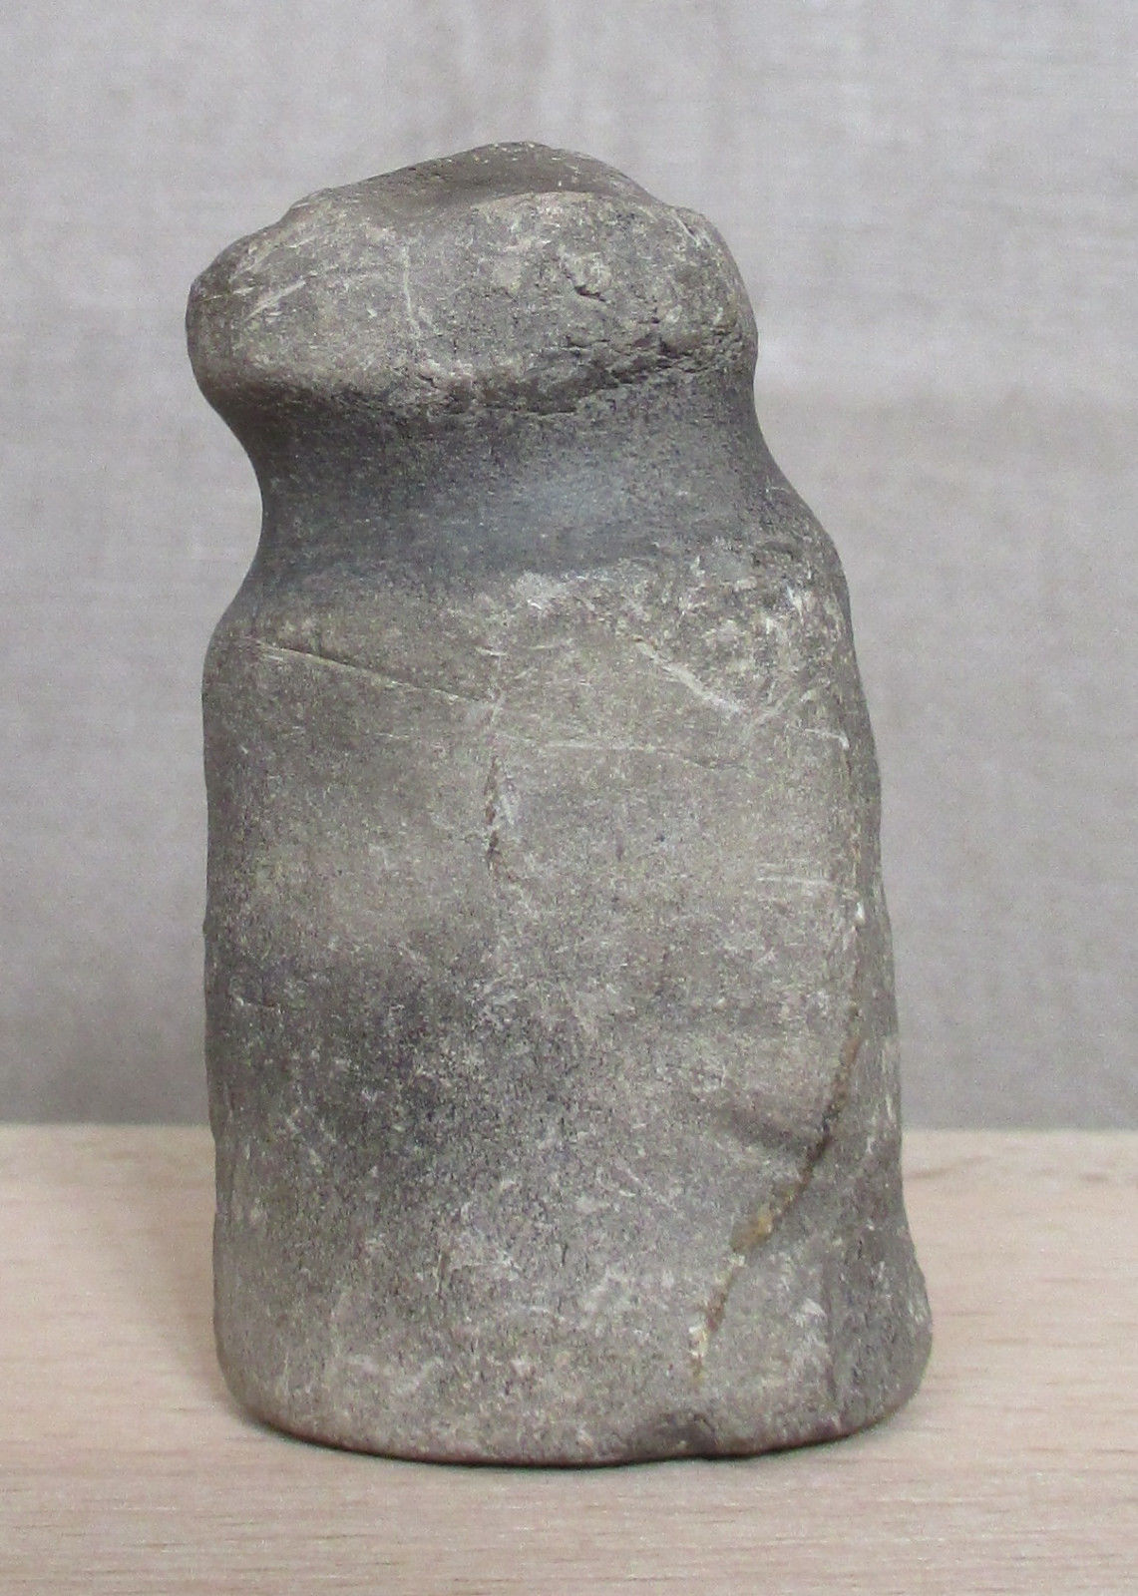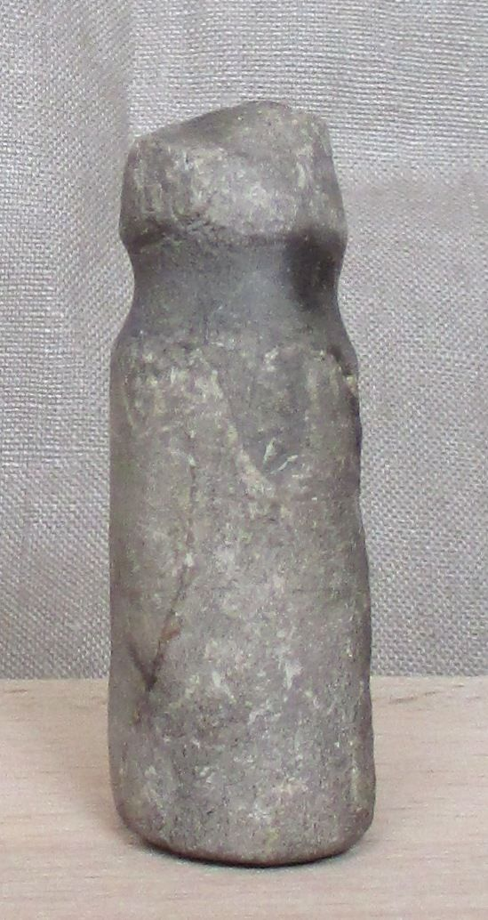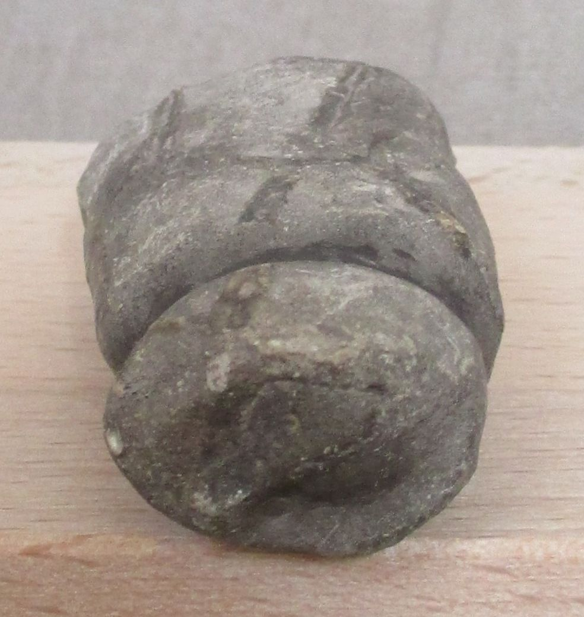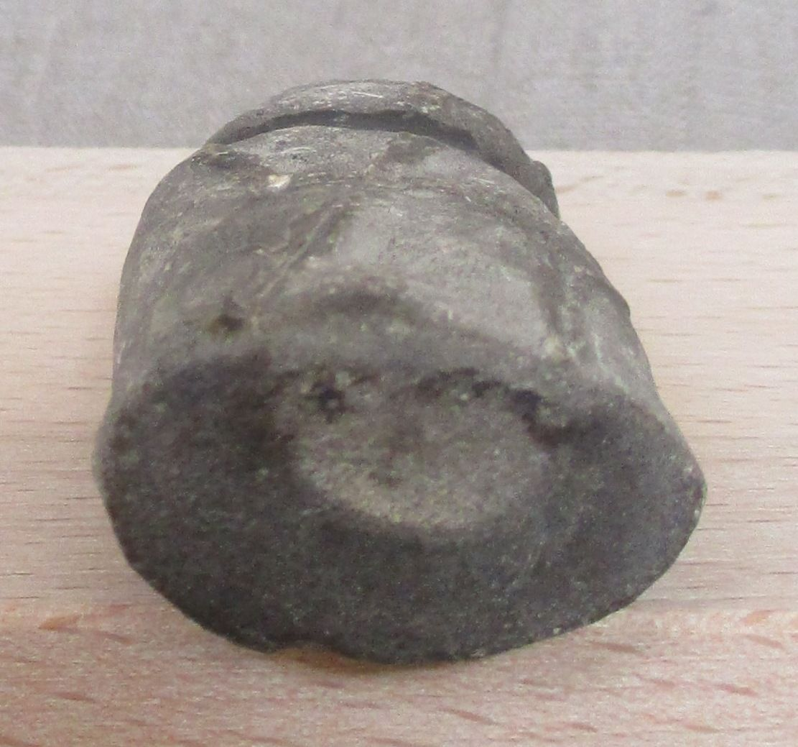

Fig. 1, a-d. Paleolithic Venus figurine from Predmosti**́**, Moravia, Czech Republic, dating to the Würm glaciation, ca. 26,000 BP.

Formal Label: Paleolithic Venus figurine from **Predmostí Moravia**, Czech Republic, dating to the **Würm glaciation**, ca. 26,000 BP

Accession Number: **DB550.A1**

Date or Time Horizon: **26,000 BP**

Geographical Area: **Predmostí, Moravia,** Czech Republic

Cultural Affiliation: **Pavlovian period**

Medium: **Limestone**

Dimensions: **H 5.2 cm x 2.8 cm x 1.8 cm (ca. 2.05 x 1.10 x 0.71 in)**

Weight: 43 gm

Provenance: **J. M. R., St Jean Cap, Ferrat, France, from a private archaeologist’s collection from a Spanish inheritance; Atlantika collection 2016.**

This figurine is very similar to those unearthed figurines carved from mammoth metatarsals at Predmosti**́** near Prerov, dated to 26,800 BP now in the Moravian Museum in Brno, Czech Republic, Based on the fact that this figurine is carved from limestone, it suggests that either mammoth metatarsals were no longer available or that the choice of a limestone medium was preferred or more readily available to the artist. If these hypotheses are correct then this figurine might date to a time horizon not long after the very similar figurines were carved from mammoth metatarsals at Predmosti**́**. Therefore the time horizon for this figurine would be ca. 26,000 BP (see Fig. 3).

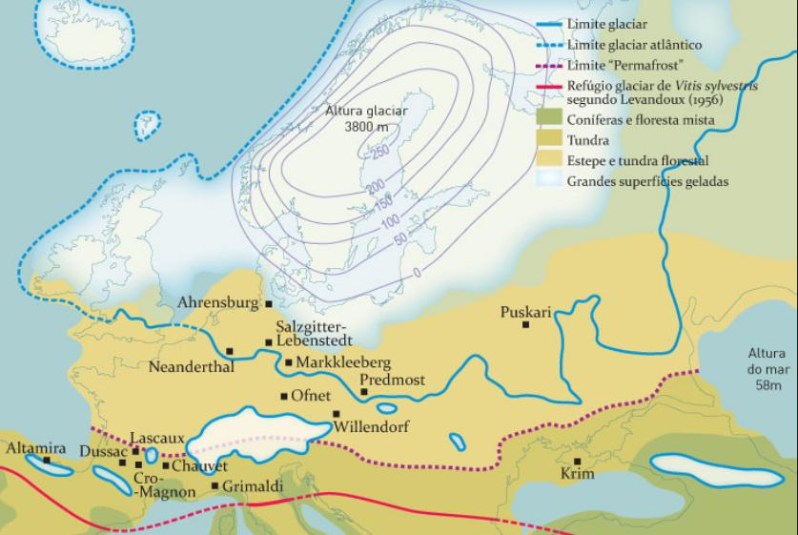

Fig. 2. Map showing location of Predmosti**́** with the landscape and vegetation in the Würm / Weichsel glaciation. From http://www.vinetowinecircle.com/wp-content/gallery/genetica-reflexoes/thumbs/thumbs_fig02.jpg

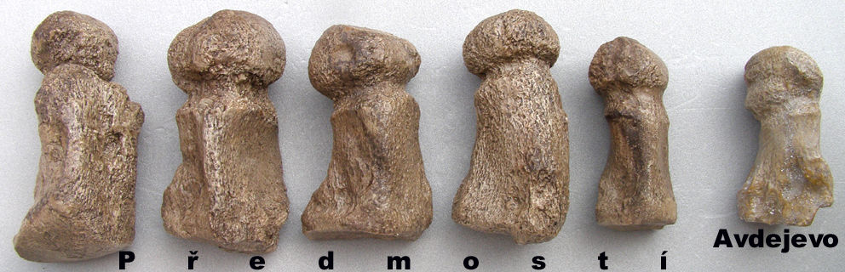

Fig. 3. A series of five pregnant women known as Venus figurines carved from mammoth metatarsals at Predmosti**́** near Prerov, Moravia, dated to 26,800 BP, now in the Moravian Museum in Brno, Czech Republic, Anthropos Institute, accession inv. 11673. The Venus far left is 14.5 cm (5,8 inches) in height Venus far right of (Avdejevo) is 10.0 cm (4,0 inches). After <http://i.ebayimg.com/00/s/MzIwWDk5Mg==/z/VbUAAOSwr81USBwg/$_14.JPG>.

**References:**

# Absolon, K., Bohuslav Klíma. 1977. *Predmostí : ein Mammutjägerplatz in Mähren*. **Brno: Archeologický Ústav Ceskoslovenské Akademie Ved v. Brno.**

# Levadoux, L., 1956. *Les populations sauvages et cultivées des Vitis vinifera L* (Vol. 1). Institut national de la recherche agronomique.